Name:
Assessment Workbook
Float or Sink
What do I need to do:
In this unit we have looked at how boats float and what materials float. It is now your turn to use your knowledge to design and make a boat.
- You need to think about what materials and tools you will use.
- Your boat must be able to float and move in the water.
- You need to answer all questions in this worksheet.
- Your teacher has given you a group to work in. Write their names below.
My Group -
Our design: use the space below to design your boat, don’t forget to use labels.

Remember when thinking about what materials to use, they must be already be in the classroom or something you can bring from home.
Materials we need to make our boat
Please remember the materials must be available in the classroom or need to be brought in from home.
Materials we need to collect | What part of the boat is this for | How many we need

Task Notes and Photos………
Make some notes about each step, so the teacher can read about what you did. There are some places your teacher will take photos for you to add to your report.
STEP 1 – Design
Why did your group decide on this design?

STEP 2 – Materials
Why did your group choose these materials?

STEP 3 – Construction
Describe how your group made the boat?

Photo taken during construction Photo taken during construction
Step 4 – Testing
What happened when your groups boat was put in the water?

Did the boat float or sink?

Why do you think this happened?

Photo of finished boat……. Photo of boat on the water……….
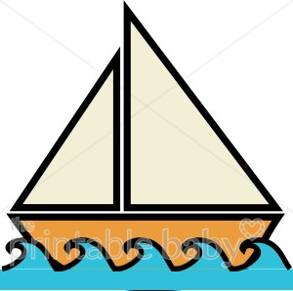
Individual Worksheet
Answer the following questions about designing and making boats:
- One thing I learnt during this topic is

- One thing that worked about my boat design is

- One thing that I could improve about my boat design is

- One thing I really liked doing in this project was

- One thing I am good at in design and technology is

You have now finished this workbook. If you finished before others you can colour in the next page.
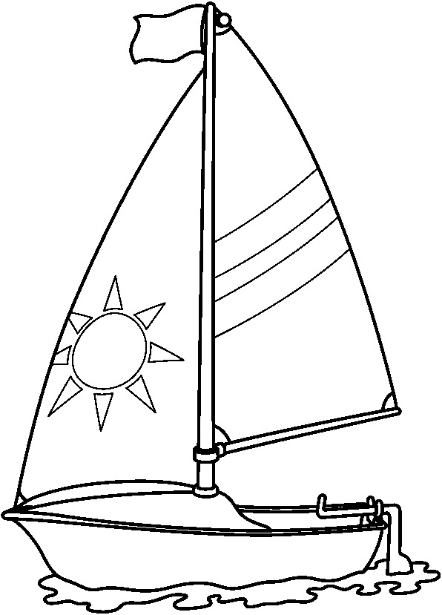
Our class has been designing and making boats.

