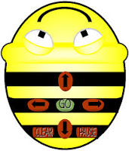

MAKE YOUR OWN PATH FOR BEE-BOT TO FOLLOW
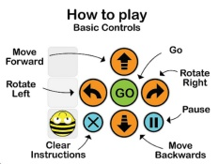

- Design a sequence of moves to make Bee Bot travel around the grid.
- Draw where your Bee Bot will travel.
- Test your instructions with your Bee Bot.

