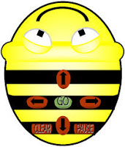
FINISH
START

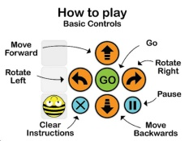

- Design the sequence of moves needed to make Bee Bot follow the grid above.
- Enter your commands on your Bee Bot and press go.
- Compare your results with the picture above.

